Cells to Organisms
Fill in the boxes using the terms below.

Organelle | Cell | Tissue | Organ | System
◆            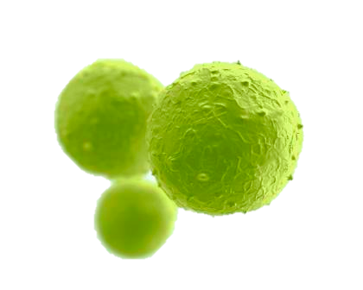 | ◆         | ◆       | ☐  ☐  ☐  ☐  ☐  ☐  ☐  ☐  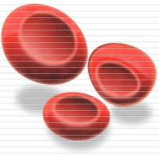  ☐  ☐  ☐ | ☐  ☐  ☐  ☐  ☐

Terms:
skeletal | epithelium | red blood cells | skin | cell membrane | nerve
kidney | small intestine | muscle | cytoplasm | pharynx | digestive
stomach | lysosome | liver | osteoblasts | lung | trachea
ribosome | excretory | nucleus | heart | mitochondria | connective
white blood cells | pancreas | respiratory | large intestine | circulatory

